1.create the master and slave1 and slave2 instances.

Download java,git,tomcat,jenkins on master instance.

Download java,git,maven,tomcat on slave1 and slave2.

Open the jenkins interface and go to manage jenkins integrate the jenkins with maven.

Establish the SSH connection between the master and slave1 and also with master and slave2 using the node. Add the maven tool and some environmental variables while creating the node.

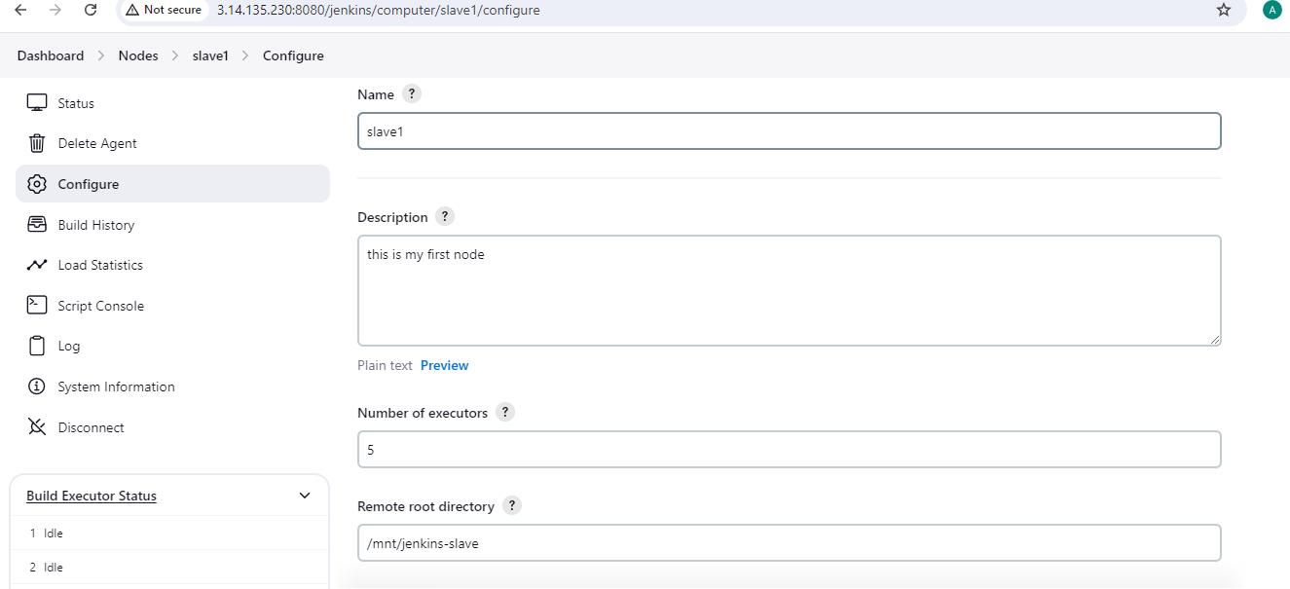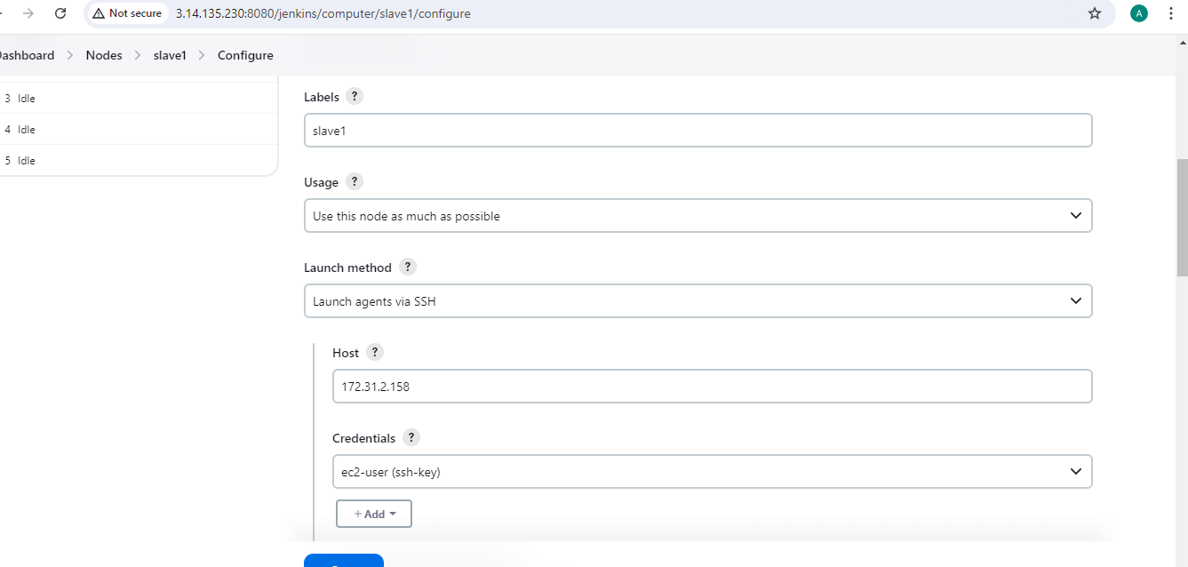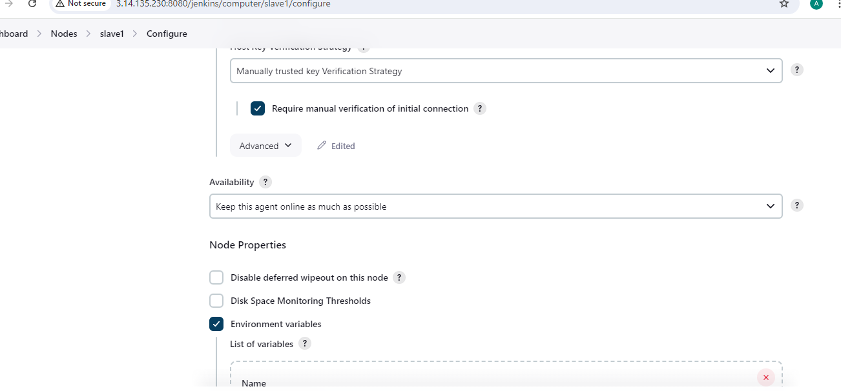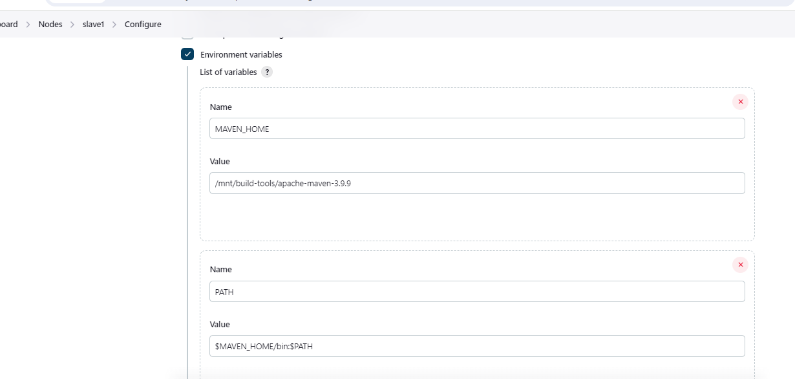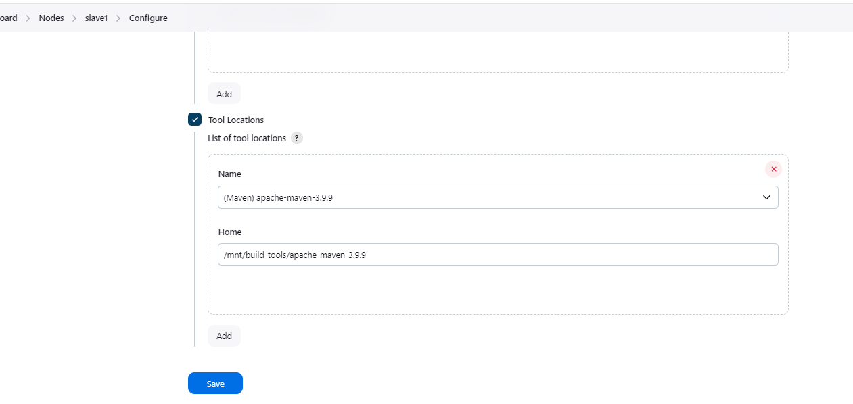created the job1 and job2 to host the war application on slave1 and slave2 and create the war files also on the slave machines.

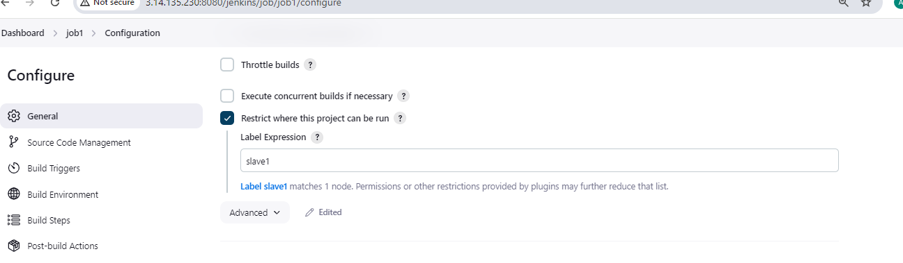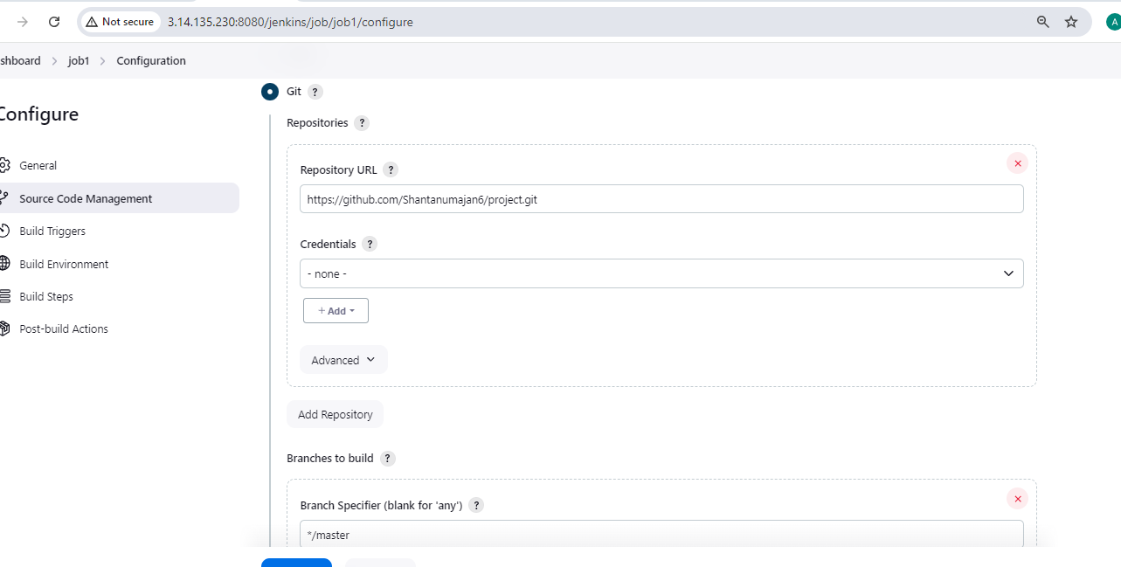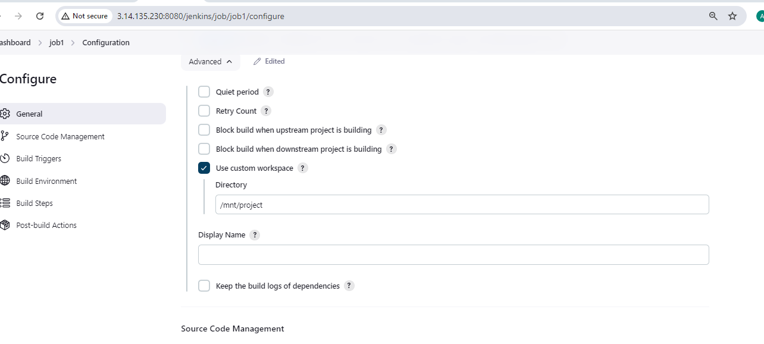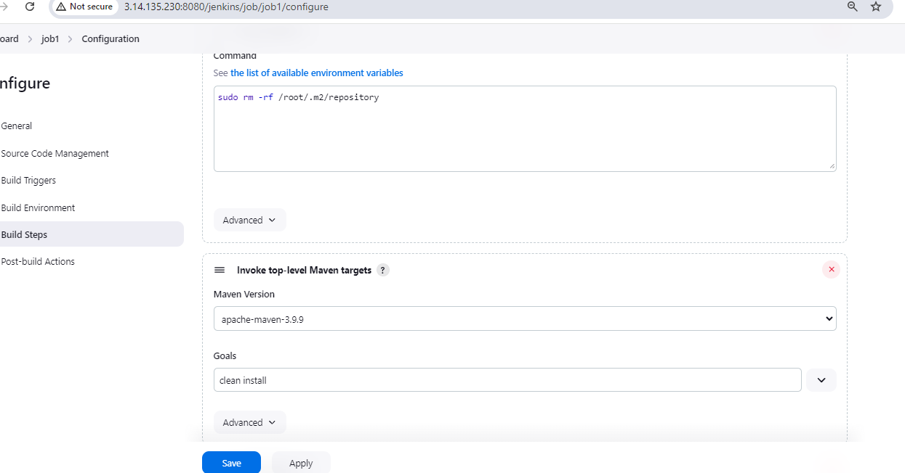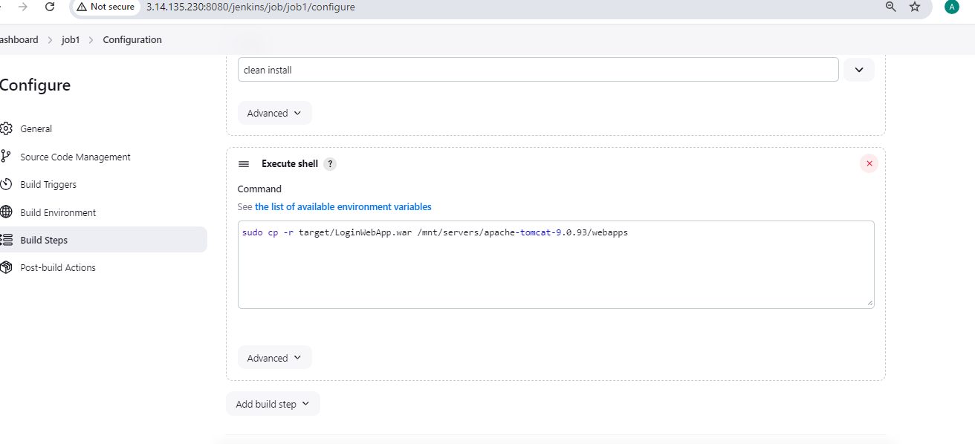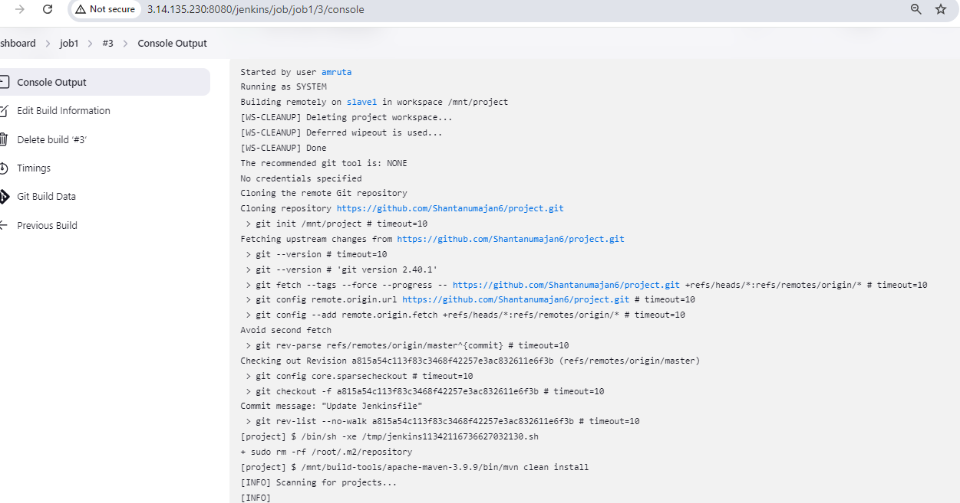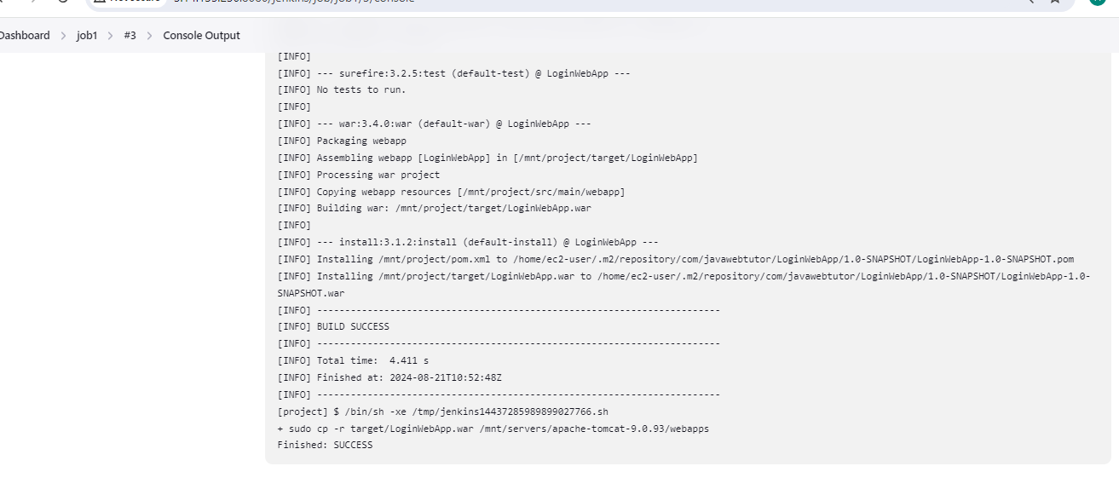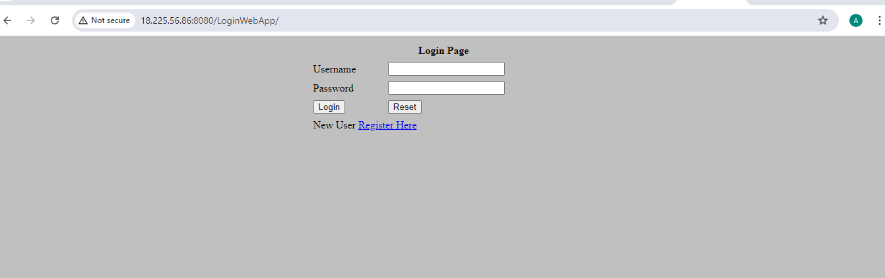same process done for slave2 machine.